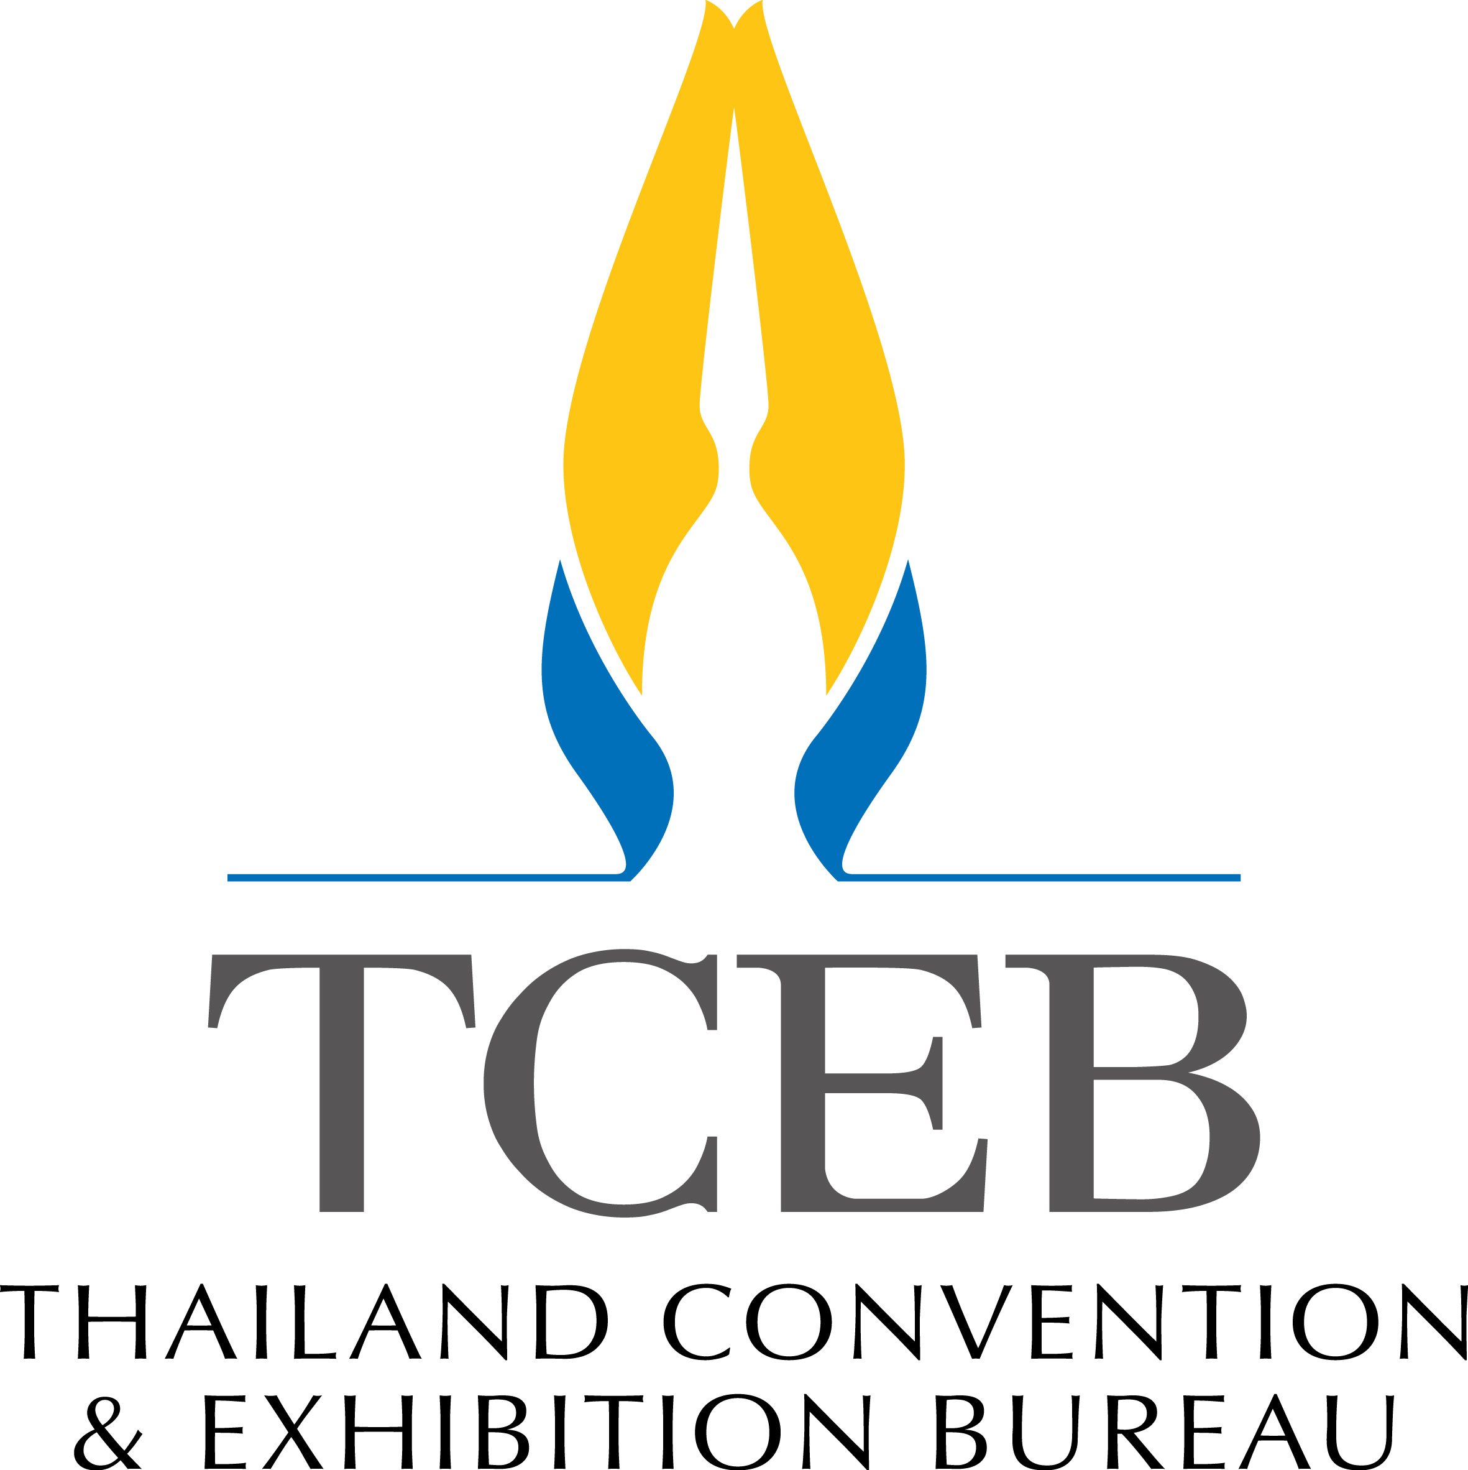

Thailand MICE Roadshow to Paris 2018
Paris, France
Friday 18th May 2018
as of January 4, 2018
Thailand MICE Roadshow to Paris 2018
Date: Friday 18th May 2018
Time: 12.00 – 16.15 hrs.
Venue/Room: TBA
Dress code: Business attire

Attendance:
      - Approx 40 Buyers (corporate travel agents, incentive houses, meeting planners etc.)
      - 10 Thai seller organizations (Maximum of 2 pax per organization to join the roadshow)
      - TCEB staffs & VIPs

Program
12.00 hrs. Arrival of Thai sellers
12.15 – 12.45 hrs. Market briefing to sellers by Mrs. Lindsey Thorpe, TCEB Representative
12.45 – 13.15 hrs. Arrival of guests
13.20 – 13.25 hrs. Opening remarks by TCEB (Khun Nooch Homrossukhun, Director of MI)
13.25 – 13.40 hrs. Destination presentation by Mrs. Lindsey Thorpe, TCEB Representative
(Presentation will be conducted in English and translated into French)
VDO Presentation
13.45 – 15.45 hrs. Business Session & Networking
15.45 hrs. Lucky draw
16.15 hrs. Program ends

**program can be adjusted where appropriate**

